
Sec 7.3 – Euler Circuits & Paths
Networks & Graphs Name:

Some brainteaser problems involving networks like the following simply cannot be done. The famous Konigsberg bridge problem is one of them. It is not possible to find a path that will enable you to cross each bridge exactly once (meaning any path that a person walks over every single bridge will require that person to walk across at least one bridge more than once). Another fairly common impossible problem is drawing a path for a person to walk through each door exactly once without going back through any door more than once.
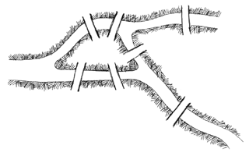

Koenigsberg Bridge Problem
The Impossible

Doorway Problem

(Can you prove Leonhard Euler wrong? Can you find a path to walk that only takes you over each bridge JUST ONCE? | (Can you prove Leonhard Euler wrong? Can you find a path to walk that only takes you each door JUST ONCE?)
(Can you prove Leonhard Euler wrong? Can you find a path to walk that only takes you over each bridge JUST ONCE?)

If the following graphs can be created without picking up your pencil and without ever retracing any edge, the graph is said to be traversable of these some are referred to as Euler Circuits or Euler Paths. Can you determine which are traversable? Circle the ones that are:
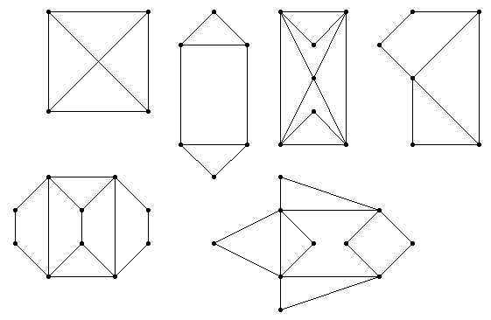
A
B
C
D
H
G
F
E
I
K
L
M
N
O
P
Q
R
S
T
U
V
W
X
Y
Z
α
β
χ
δ
ε
φ
γ
J
1
2
3
4
5
6
7
8
9
10
Example that is traversable.
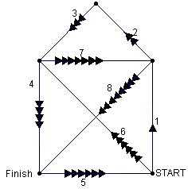

v
Alternately, you can label each vertex and then list the vertices in order that would complete the graph.

Student Worksheets Created by Matthew M. Winking at Phoenix High School SECTION 7-3 p.90

- a. Label the degree of each vertex
    - Put a CIRCLE around the following graphs that have an EULER CIRCUIT and list a possible circuit. Briefly explain why an Euler Circuit must have all even degree vertices.

    - Put a SQUARE around the following graphs that have an EULER PATH and list a possible path. Briefly explain why an Euler P must have exactly 2 odd vertices and the rest even.

M
•
•
•
•
•
•
I
G
C
•
•
•
•
•
•
•
•
•
•
•
•
P
D
B
O
R
N
Q
K
J
F
E
A
L
H

X
•
•
•
•
•
•
•
α
Z
Y
W
β
V
T
•
•
•

U
S

- Create a Graph of the following map and explain whether it is impossible or possible to pass through each door exactly once.
Room C
Room A
Room D
Room B
OUTSIDE
OUTSIDE
ROOM A
ROOM B
ROOM C
ROOM D
ROOM E

Student Worksheets Created by Matthew M. Winking at Phoenix High School SECTION 7-3 p.91

